What is S.A.F.E.?



Self Defense Awareness Fundamentals for Everyone, S.A.F.E. is an advance yet simple system designed for:

Crime Prevention
Personal Safety
Self-Defense
General Wellness

How much more fulfilling would your life be, and how much more freedom would you experience if you knew how to recognize and respond to a potentially dangerous situation?

Between 60%-70% of assaults against women were unsuccessful primarily due to the woman taking some type of protective measure. Statistics also show that the greater number of defensive methods employed during an attack, the higher the chance of escape… attackers prefer “easy” victims! S.A.F.E. gives participants the proper tools for various situations.

How is this program different?

S.A.F.E focuses on the physical, emotional and psychological aspects of an attack through a hands-on and lecture combination that allows students to practice the self-defense techniques. S.A.F.E. program draws on years of experience in various types of self-defense and martial arts to educate and prepare you to learn counter strategies to protect yourself and those you love.

S.A.F.E. helps turn fear into effective self defense energy.
The course will address lack of confidence, helplessness, and anger. This course will signal a new awareness of your physical potential, emotional strength and confidence.

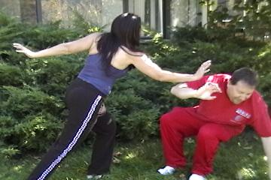

Can I Do This?

Absolutely! We create an environment where you feel comfortable enough to challenge yourself and discover your strength. You will learn to use your entire body, regardless of your strength, size body type or level of fitness. Students of up to 81 years of age have completed this course. Determination and the desire to take control of your life is all that is required.

The truth about physical violence in America is shocking:
FBI Statistics
- Somewhere in America, a woman is raped every 2 minutes, according to the U.S. Department of Justice
- In 29% of rapes, the offender used a weapon.
- Four women die every day in this country as a result of domestic violence.
- Conservative estimates indicate two to four million women of all race and class are battered each year. At least 170,000 of those violent incidents are serious enough to require hospitalization, emergency room care or a doctor's attention.

The more prepared you are to defend yourself; the less likely you will ever have to.

Training available for:

- Corporate Groups

- Individual Groups

- Schools

- Associations

- Individuals/Friends

Specialized Courses Designed for:

- Adults

- Teenagers

- Young Children

- Elderly

IT’S YOUR LIFE ~ TAKE CONTROL OF IT

How to contact us:
For information on seminars or private training
Terri Carrigan
720-838-4401
TNCDenver@gmail.com

S A
F
E



For

Certified and endorsed by Cecil Peoples, Founder and Grand Master Instructor of
Peoples Kenpo Karate

